A

Project Report on

Submitted in partial fulfillment of completion of the course

Advanced Diploma in IT, Networking and Cloud

Submitted by:

**Muskan & Sumit**

***iPhone Sales Analysis using Python***

|  |  |  |
| --- | --- | --- |
| IBM-Logo - Chicago Innovation | DGT introduces high end diploma courses - digitalLEARNING Magazine | Edunet Foundation-Delhi- CSR Organization profile |

Year 2022-24

***iPhone Sales Analysis using Python***

Apple [**iPhones**](https://thecleverprogrammer.com/2022/08/19/use-cases-of-machine-learning-in-an-iphone/) are among the top-selling smartphones worldwide. There is huge competition among smartphone brands in India, where you can get the latest technology in a smartphone at half the price of an iPhone. Still, there are high sales of iPhones in India. So if you want to analyze the sales of iPhones in India, this article is for you. In this article, I will take you through the task of iPhone Sales Analysis using Python.

**iPhone Sales Analysis using Python**

For the iPhone sales analysis task, I have collected a dataset from Kaggle containing data about the sales of iPhones in India on Flipkart. It will be an ideal dataset to analyze the sales of iPhones in India.

Now let’s import the necessary Python libraries and the [**dataset**](https://www.kaggle.com/datasets/komalkhetlani/apple-iphone-data) to get started with the task of iPhone sales analysis:

ABRACTS

The realm of iPhone Sales Analysis is a multifaceted tapestry woven with interconnected concepts and mechanisms, forming a dynamic ecosystem where sales metrics dance to the rhythm of market forces. It transcends the concrete realm of units sold and revenue figures, evolving into a conceptual landscape where the ebb and flow of consumer demand converges with the principles of marketing strategies and technological advancements.

This conceptual space is painted with the hues of market trends and consumer preferences, uncertainty and strategic planning. It is not merely a quantitative analysis of sales figures but a theater where consumer behavior meets marketing strategies. In this abstract space, analytical algorithms hum silently, translating vast datasets into predictive patterns, while analysts navigate the currents of market fluctuations and competitive landscapes.

Acknowledgment

I am deeply grateful to all those whose support and contributions have been instrumental in the successful completion of the iPhone Sales Analysis project. Without their guidance, encouragement, and resources, this endeavor would not have come to fruition.

I extend my heartfelt appreciation to NSTI NOIDA for providing valuable resources and a conducive environment for the development of our project. Special thanks go to our mentor, Mrs. DEEPIKA SINGH from IBM, whose expertise and guidance were invaluable throughout the project's journey.

I would also like to express gratitude to all individuals who, though not specifically mentioned, have played a role, no matter how small, in the realization of this project. Their collective efforts have significantly contributed to the depth and success of our analysis of iPhone sales data.

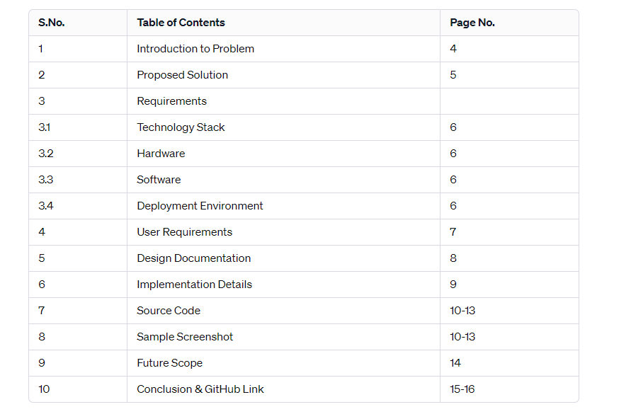 Top of Form

1 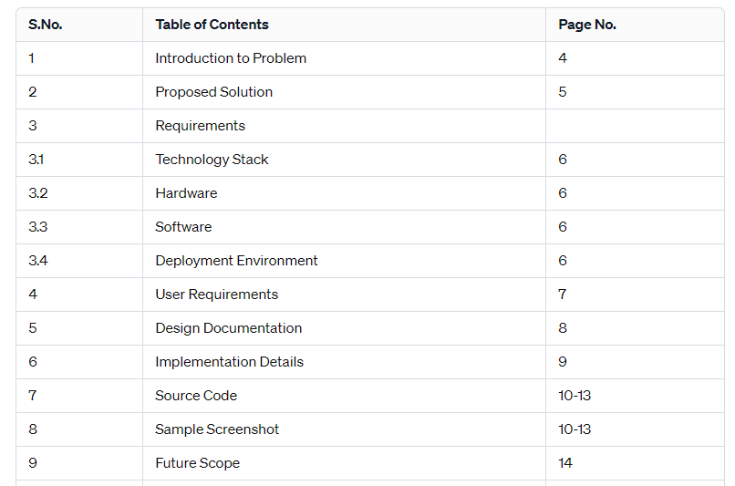

INTRODUCTION to PROBLEM

Understanding the intricacies of iPhone Sales Analysis is imperative for anyone seeking insights into market trends and consumer behavior. Whether you're a seasoned analyst or new to the field, conducting comprehensive research, staying abreast of sales patterns, and seeking expert advice are crucial steps in making informed decisions regarding iPhone sales data. It's important to note that analyzing sales figures always involves complexities, and approaching this aspect with a well-defined strategy aligned with your analytical goals is essential for deriving meaningful insights.

Top of Form

U

Market Dynamics for iPhone Sales Analysis:

1. **Demand Fluctuations:** iPhone sales can exhibit fluctuations based on consumer demand influenced by factors such as technological advancements, marketing strategies, and consumer preferences.
2. **Sales and Profitability:** Similar to stock returns, the potential for higher iPhone sales and profitability may come with increased market competition and varying levels of risk. Evaluating market dynamics is crucial for managing potential risks and optimizing returns.
3. **Consumer Behavior:** Understanding consumer behavior is essential for analyzing iPhone sales. Factors like brand loyalty, pricing strategies, and response to new features contribute to the dynamics of iPhone sales.
4. **Market Participants:** Various entities, including individual consumers, retailers, competitors, and distributors, contribute to the iPhone sales landscape. Recognizing the roles of these participants is vital for comprehending market trends and potential challenges.
5. **Market Trends and Indices:** Tracking trends in the smartphone market, considering competitors' performance, and analyzing market indices specific to the tech industry can provide insights into the overall performance of iPhone sales.
6. **Economic Influences:** Economic factors, such as disposable income, consumer spending, and global economic conditions, can impact iPhone sales. Monitoring economic indicators relevant to the consumer electronics market is crucial for informed decision-making.
7. **Analytical Methods:** Employing both quantitative and qualitative analyses is essential for comprehending iPhone sales dynamics. This includes assessing historical sales data, market share trends, and consumer feedback.
8. **Technological Advancements:** Rapid technological changes, such as the introduction of new iPhone models or advancements in features, can significantly influence consumer demand and market dynamics.
9. **Regulatory Environment:** Similar to stock markets, the smartphone industry is subject to regulations. Compliance with industry standards and regulations, along with monitoring changes in policies, is vital for adapting to the evolving landscape of iPhone sales.
10. **Competitive Landscape:** Analyzing the strategies of competitors, market positioning, and response to market changes is crucial for understanding the dynamics of iPhone sales and maintaining a competitive edge.

Problem solution

1. **Utilize Analytical Tools and Technologies:** Leverage data analytics tools, market research platforms, and sales tracking applications to gain real-time insights into iPhone sales trends, consumer behavior, and market dynamics.
2. **Establish a Sales Performance Dashboard:** Create a visual representation of iPhone sales data using dashboards or reporting tools. This can help in monitoring key performance indicators, identifying patterns, and making informed decisions.
3. **Diversify Data Sources:** Explore various data sources such as customer surveys, social media analytics, and industry reports to gather comprehensive information on consumer preferences, competitor strategies, and market trends impacting iPhone sales.
4. **Emergency Response Plan for Sales Fluctuations:** Develop a strategy to address unexpected variations in iPhone sales. This plan may include flexible marketing campaigns, inventory management adjustments, or pricing strategies to adapt to changing market conditions.
5. **Strategic Decision-Making:** Encourage a strategic, data-driven approach to decision-making within the sales team. This involves analyzing historical sales data, understanding the impact of product launches, and identifying opportunities for improvement.
6. **Long-Term Sales Forecasting:** Adopt a long-term perspective when analyzing iPhone sales data. Consider trends over extended periods to make more accurate sales forecasts and develop sustainable growth strategies.
7. **Risk Management and Contingency Planning:** Evaluate potential risks to iPhone sales, such as changes in consumer preferences or economic downturns. Develop contingency plans to mitigate these risks and ensure resilience in the face of market uncertainties.
8. **Engage with Market Experts:** Collaborate with industry experts, market analysts, or consultants specializing in the smartphone industry. Their insights can provide a deeper understanding of market dynamics and contribute to more informed decisions regarding iPhone sales.
9. **Continuous Market Monitoring:** Implement a system for continuous monitoring of the smartphone market. Stay updated on competitor activities, industry trends, and technological advancements that may impact iPhone sales.
10. **Regular Performance Reviews:** Conduct regular reviews of iPhone sales performance against set targets and key performance indicators. Identify areas for improvement, assess the effectiveness of marketing strategies, and make data-driven adjustments to enhance sales outcomes.

Top of Form

* **Project Requirement**

|  |  |
| --- | --- |
| Project Name | iPhone sale Analysis |
| Language used | NUMPY,METPLOTLIB,PANDAS,PYPLT |
| Editor | GOOGLE COLLAB |
| User Interface Design | JUPITERNOTEBOOK & GOOGLECOLAB |
| Web Browser | JUPITERNOTEBOOK & GOOGLE COLAB |
| Database | N/A |

User Requirements for iPhone Sales Analysis:

1. **User Type:**
   * Identify whether the user is an individual consumer, a retailer, or a distributor involved in iPhone sales.
   * Understand the specific role and needs of the user within the iPhone sales ecosystem.
2. **Eco-Friendly Considerations:**
   * Recognize the preference of eco-conscious consumers who may be interested in purchasing iPhones with sustainable features.
   * Provide information on environmentally friendly aspects of iPhone models, such as energy efficiency or use of recycled materials.
3. **Sales Performance Metrics:**
   * Understand the user's key performance indicators for iPhone sales, such as units sold, revenue generated, and market share.
   * Address specific metrics relevant to the user's role, such as retail sales performance or distributor inventory turnover.
4. **Market Trends and Consumer Behavior:**
   * Assess the user's interest in staying informed about market trends, consumer preferences, and competitor activities related to iPhone sales.
   * Provide insights into the latest trends in iPhone models, consumer demand, and competitive positioning.
5. **Risk Analysis for Inventory Management:**
   * Understand the user's risk tolerance regarding iPhone inventory management.
   * Provide tools or insights to manage inventory risks, such as overstock or stockouts, based on market demand fluctuations.
6. **Investment Horizon for Retailers and Distributors:**
   * Determine whether retailers and distributors have a short-term or long-term investment horizon concerning iPhone inventory.
   * Align inventory strategies with the user's investment goals and market expectations.
7. **Real-time Sales Data:**
   * Offer real-time data on iPhone sales, including units sold, revenue, and regional sales trends.
   * Provide timely updates on product launches, promotions, and other factors influencing iPhone sales.
8. **Sales Forecasting Tools:**
   * Provide forecasting tools for retailers and distributors to predict future iPhone sales based on historical data and market trends.
   * Enable users to make informed decisions regarding inventory levels and promotional activities.
9. **Competitor Analysis:**
   * Offer tools for analyzing the performance of competing smartphone brands and models.
   * Provide insights into competitor pricing strategies, market share, and customer satisfaction to inform the user's sales strategy.
10. **Customizable Dashboards:**
    * Allow users to customize dashboards to track specific metrics relevant to their iPhone sales objectives.
    * Ensure ease of use and accessibility for users with varying levels of technical expertise in the field of iPhone sales.

Top of Form

Bottom of Form

p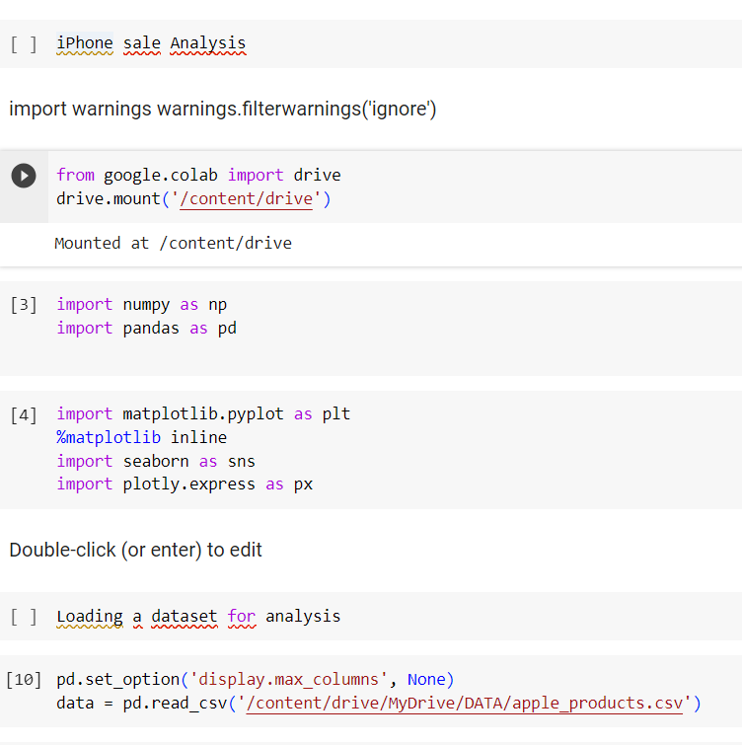

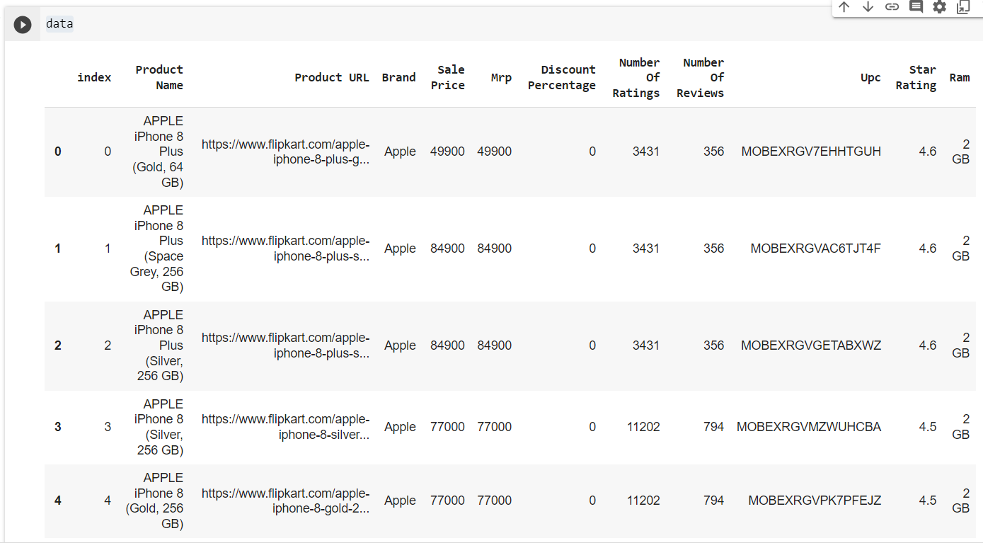

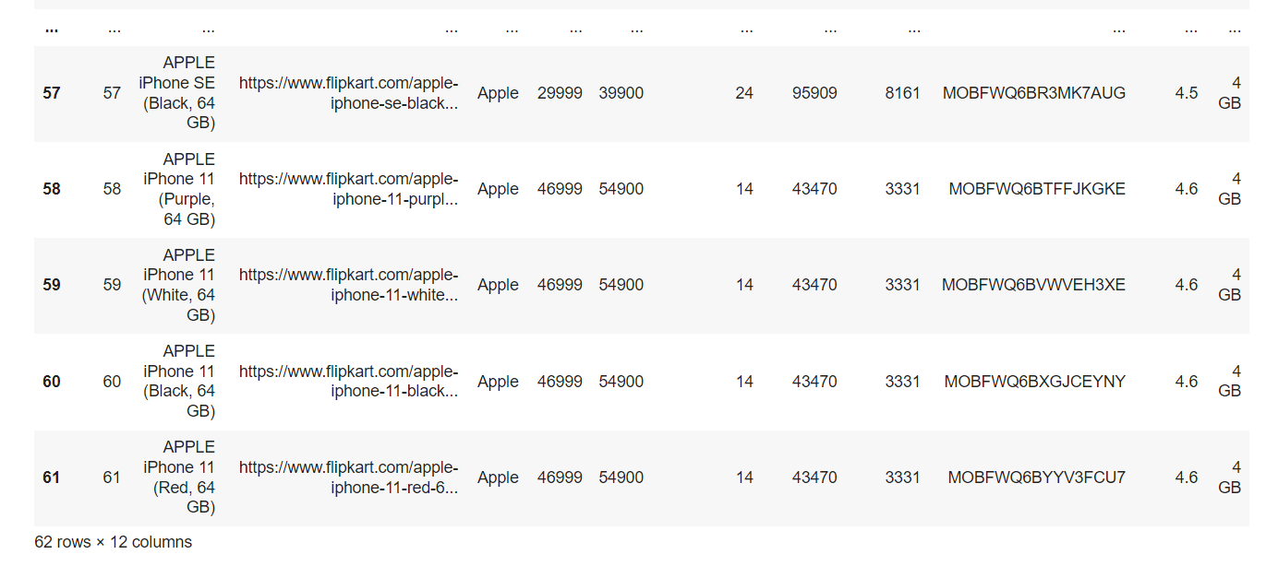

Before moving forward, let’s have a quick look at whether this dataset contains any null values or not:

1

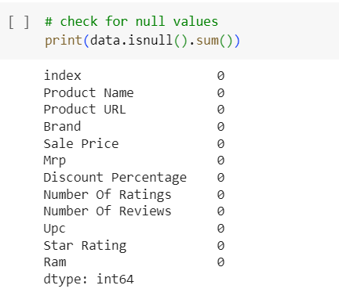

The dataset doesn’t have any null values. Now, let’s have a look at the descriptive statistics of the data:

1

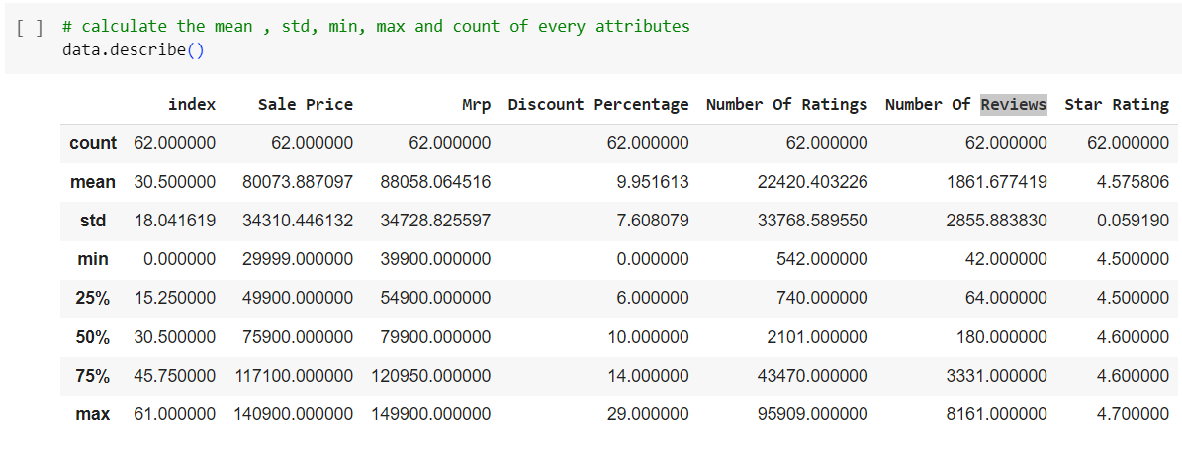

**Number Of Reviews Star Rating**

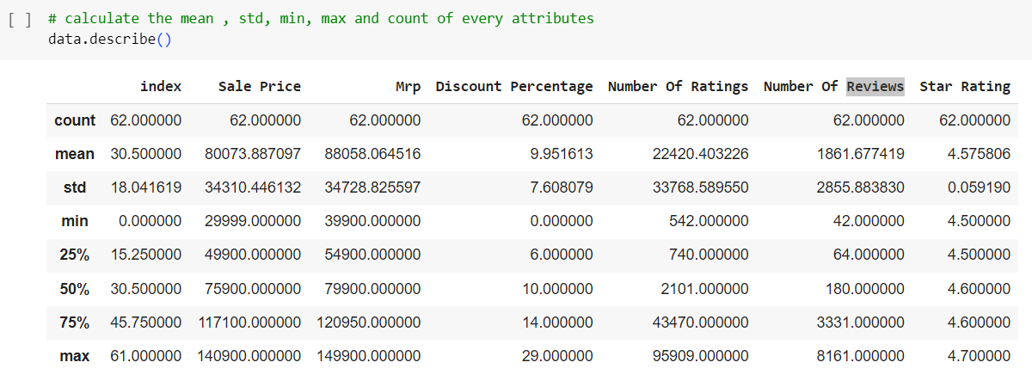**iPhone Sales Analysis in India🇮🇳**

Now I will create a new dataframe by storing all the data about the top 10 highest-rated iPhones in India on Flipkart. It will help in understanding what kind of iPhones are liked the most in India:

1

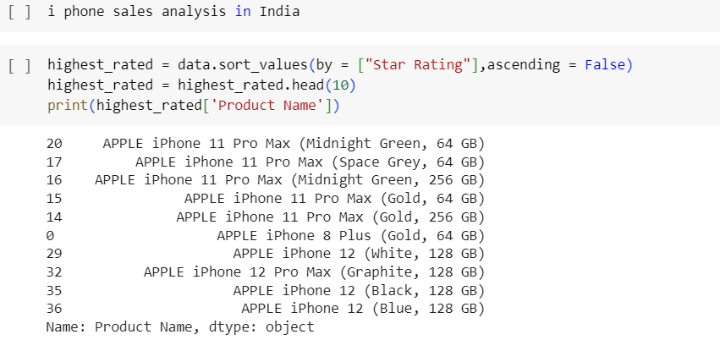According to the above data, below are the top 5 most liked iPhones in India:

1. APPLE iPhone 11 Pro Max (Midnight Green, 64 GB)
2. APPLE iPhone 11 Pro Max (Space Grey, 64 GB)
3. APPLE iPhone 11 Pro Max (Midnight Green, 256 GB)
4. APPLE iPhone 11 Pro Max (Gold, 64 GB)
5. APPLE iPhone 11 Pro Max (Gold, 256 GB)

Now let’s have a look at the number of ratings of the highest-rated iPhones on Flipkart:

1

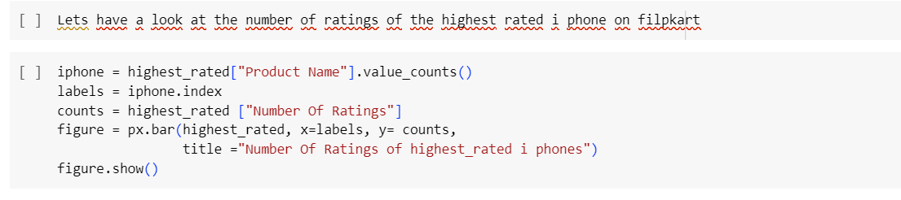

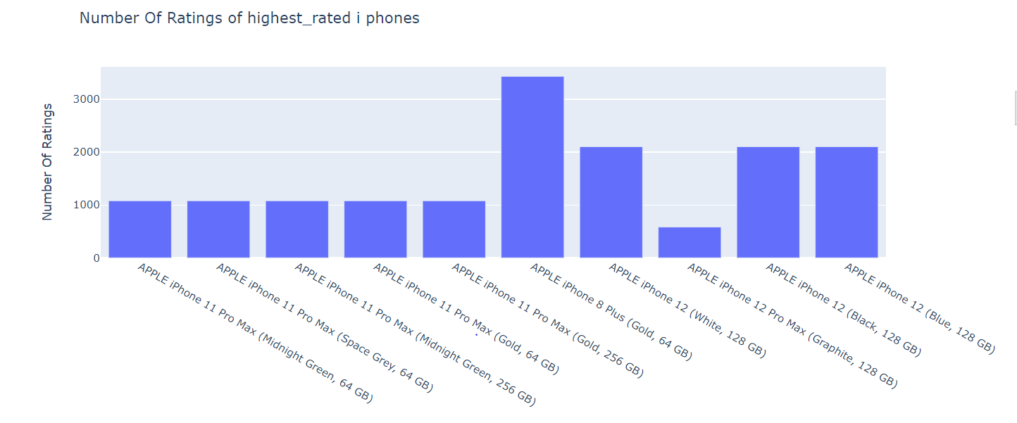

According to the above bar graph, APPLE iPhone 8 Plus (Gold, 64 GB) has the most ratings on Flipkart. Now let’s have a look at the number of reviews of the highest-rated iPhones on Flipkart:

1

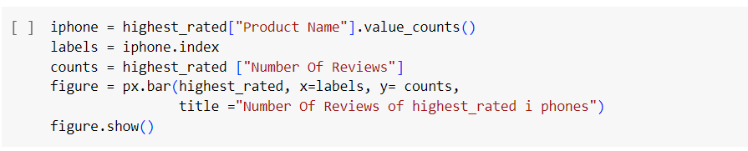5

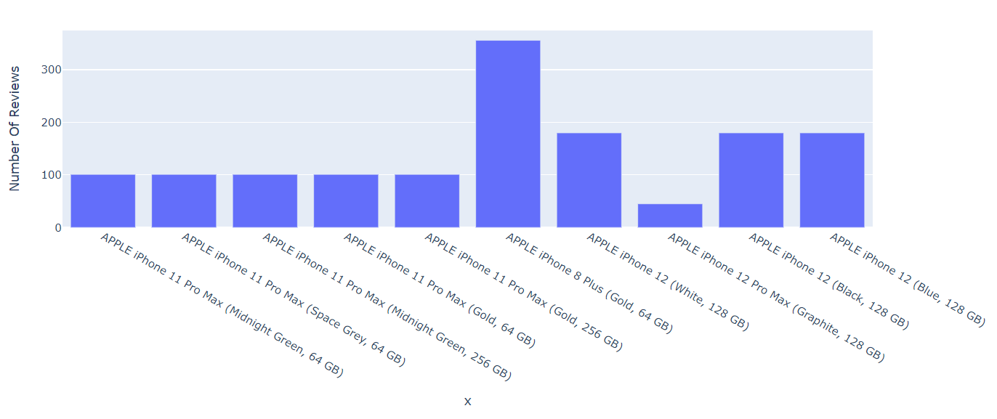7

APPLE iPhone 8 Plus (Gold, 64 GB) is also leading in the highest number of reviews on Flipkart among the highest-rated iPhones in India. Now let’s have a look at the relationship between the sale price of iPhones and their ratings on Flipkart:

1

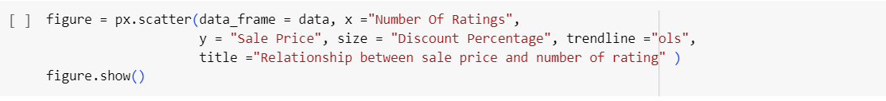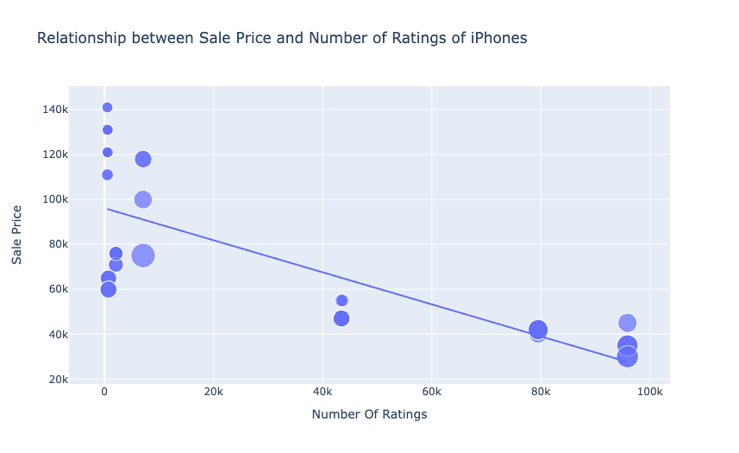

There is a negative linear relationship between the sale price of iPhones and the number of ratings. It means iPhones with lower sale prices are sold more in India. Now let’s have a look at the relationship between the discount percentage on iPhones on Flipkart and the number of ratings:

1

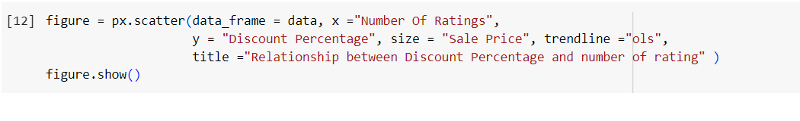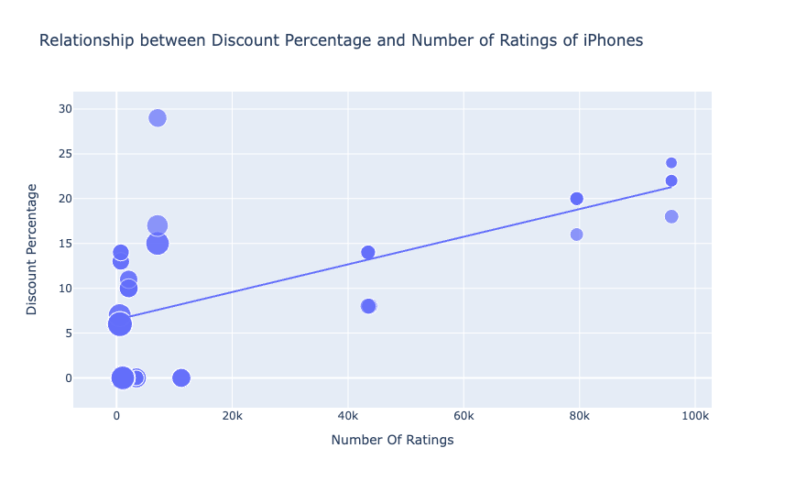

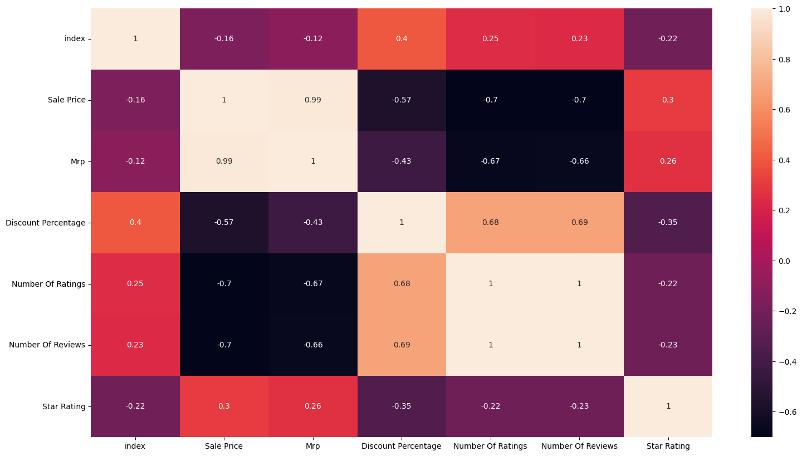

There is a linear relationship between the discount percentage on iPhones on Flipkart and the number of ratings. It means iPhones with high discounts are sold more in India.

**Summary**

So this is how you can analyze the sales of iPhones in India using the Python programming language. Some of the takeaways from this article about the sales of iPhone in India are:

1. APPLE iPhone 8 Plus (Gold, 64 GB) was the most appreciated iPhone in India
2. iPhones with lower sale prices are sold more in India
3. iPhones with high discounts are sold more in India

I hope you liked this article on iPhone sales analysis using Python. Feel free to ask valuable questions in the comments section below.